RESEARCH DESCRIPTION

- Purpose, Objectives, Design

Though the importance of food texture and flavors is explicit in the process of chewing, but the interactions between food perception, oral physiology and food properties is still ambiguous to the researchers. The properties of food such as appearances, flavor and texture, interaction with saliva, number of functional teeth and biomechanical system operations, influence the chewing process of human. The sensory properties of different food, which are typically perceived during chewing and swallowing, are one of the primary factors in food acceptance. Chewing performance and maximum chewing force measurement may provide essential and vital information that could potentially lead to appropriate diagnosis as regards masticatory process. Food texture or hardness is one of the three main essential factors (appearance, flavor and texture) of food to be acceptable. Previous research brought into attention that food texture influences the chewing process, because changes in food texture or hardness cause masticatory system to be changed [1] [2]. Most of the studies which are performed to investigate chewing strength change due to change in food texture used artificial and nonfood test materials instead of natural food. But surprisingly no artificial characterization of food hardness can completely simulate the complex oral process during chewing [3]. Within the first few chews of real food, mechanical properties changes drastically by the effect of the oral environment. The time require to change the properties of real food is very small (0.2s to 0.3s of first chew) [4]. Typically the foods we eat to take as nourishment are very different than the industrial test materials used to quantify chewing strength which eventually produce divergence as the chewable materials can or cannot be swallowed. Some previous study also provided some interesting facts that chewing force may not be related to food texture or hardness [5-8]. We aim to clarify the relationship between chewing strength and food hardness by conducting a study among healthy individuals with real chewable and swallow able food.

With the objective of exploring the relationship between real food hardness and chewing strength change, this study aims to use four different sensor systems which can detect food intake, count chew numbers and record corresponding chewing force. This study:

- will allow to explore relationship between chewing strength and food texture.
- will allow to develop a statistical test model which may help to establish relationship between food texture and chewing process.

The fundamental hypotheses of the study are:
1) Food attributes such as food textures plays a vital role in chewing process of human.
2) The chewing strength varies with food textures.

In the proposed study, we will collect sensor data from participants using four different sensors while eating different foods (carrot, banana and apple) in laboratory. The data from all four sensors will be analyzed to test our hypotheses and to evaluate chewing strength for foods with different hardness.

- Study Procedures

2.1 Measurement equipment
A total of four sensor systems will be explored and evaluated to objectively detect corresponding chewing force for different food textures. The followings are the potential options (depicted in Figure -1):
a) Behind the Ear Device: This device consists of an air pressure sensor (SM9541, from Silicon Microstructures) system and a custom molded earbud (Figure. 1a). The ear canal pressure can be analyzed to objectively detect pressure change during chewing. Figure. 2(a) shows an example of the sensor signal acquired during a short episode of food intake. The number of chew counts can be obtained from the signal. The earpiece will also contain a 5Mp camera facing down toward the food. The camera is attached with the device for capturing food images, which will be used for future work.
b) Eyeglasses with Flex Sensor: The attachment to eyeglass frame will include a short flex sensor (SpectraSymbol 2.2” flex sensor) that monitors the force applied by the temporalis muscle to the frame of the glasses and can be used to estimate chew strength. Other than difference in the sensor and form, the device operates the same as the earpiece sensor and provides the same information.
c) Eyeglasses with Piezoelectric Sensor: The wearable sensor system is connected to the temple of glasses. The piezoelectric sensor is attached with temporalis muscle by medical tape. During chewing of food will cause to change the resistance of piezoelectric sensor. The data is collected using a smartphone via Bluetooth.
d) Electromyography Sensor: The temporalis muscle movement while eating can also be recorded using electromyography (EMG) sensor. In order to collect chewing data from temporalis muscle using EMG electrodes, the low power, low cost, biomedical toolkit: ‘bitalino’ will be used. The data will be captured using ‘OpenSignals’ android application, via smartphone.
Data will be collected using four wearable sensor systems. The assignment of sensors to a specific participant will be completely random, also taking into account the availability of a specific device at the time of the experiment.
All four devices are non-significant risk device as it is not an implant, does not support life, does not present a health risk, and is not used in diagnosing or treating disease. Each four sensor systems, is based on low power, low-voltage (3V) electronics and poses no more than minimal risk, comparable to a consumer electronic device.
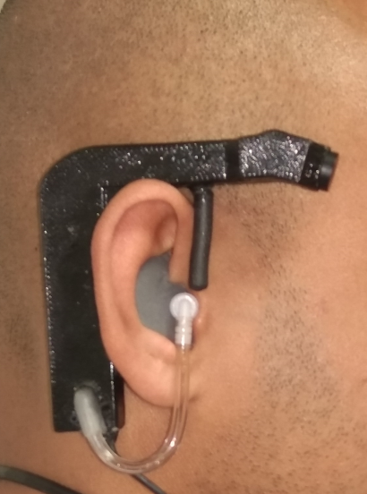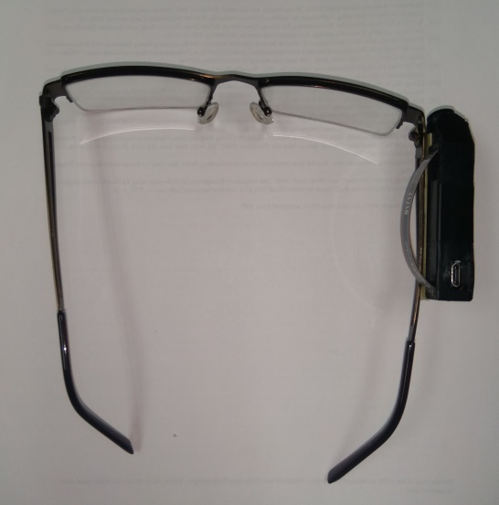
(b)
(a)
Flex Sensor
Custom Mold Earbud

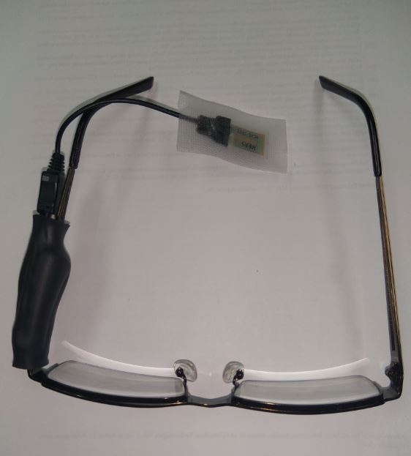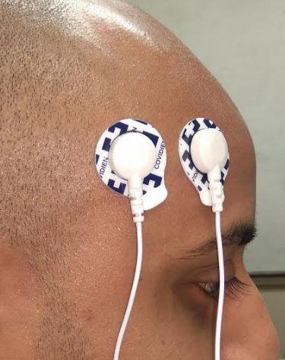
(d)
(C)
Piezoelectric Sensor
EMG
Electrodes

Figure 1: Four sensor systems: a) Behind Ear Device (Pressure Sensor) b) Eyeglass with Flex Sensor c) Eyeglass with Piezoelectric Sensor d) Electromyography Sensor System

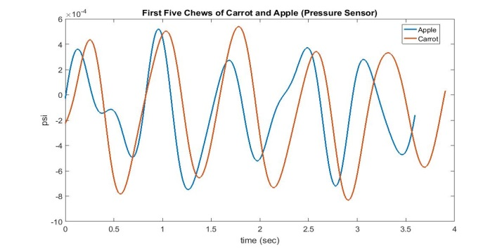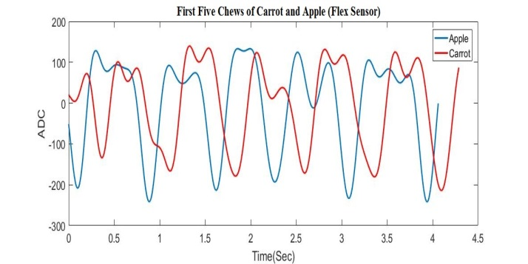
(b)
(a)

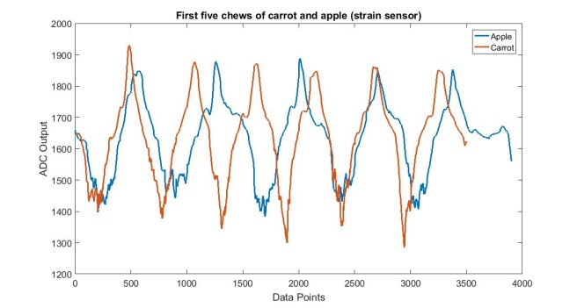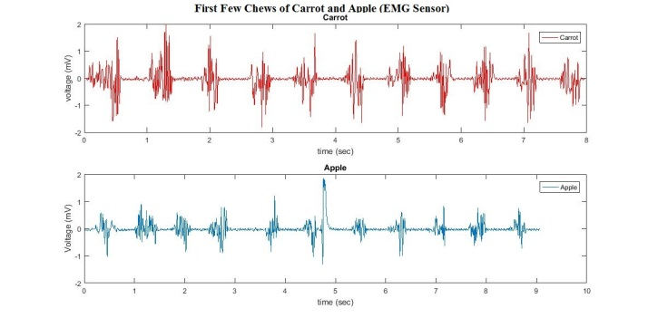
(d)
(c)

Figure 2: Example of sensor signal from a) Behind Ear Device (Pressure Sensor) b) Eyeglass with Flex Sensor c) Eyeglass with piezoelectric sensor d) EMG sensor

2.2 Experimental protocol:
Participants will come to the laboratory for two visits and spend around 30 minutes in each visit. At the first visit, the participant will go through screening process including informed consent and necessary training. At the second visit, the experiment will begin. The experiment will consists of eating three types of food a) Carrot (Hard Food) b) Banana (Soft Food) c) Apple (Medium Hard Food)
Initial visit:
The participants will be asked to come to the human participant laboratory in the morning (between 10:00AM - 12:00PM). Participants will read and sign an informed consent form (Appendix I).
After consent is acquired, participants will be briefed about the purpose, goal and procedure of the study. Participant's height and weight will be checked and recorded. A custom molded earpiece will be made for each participant, which will be used for taking data using Behind Ear Device. This will conclude the initial visit part of the study.

Experiment - Laboratory part:
The participants will be asked to come to the human participant laboratory at any suitable time of the day of their choice. After arrival, participants will be given instructions for the experiment and given the devices to wear.
Each participant has to eat three types of food:
- Carrot 2) Apple and 3) Banana

The meal will be divided into two parts
Part a) Eating half of Carrot, Apple, and Banana wearing any two of the four devices. Both devices and food will be assigned randomly.
Part b) Eating the rest half of the Carrot, Apple and Banana wearing the other two devices.
All these food items will be purchased from commercial sources (Publix, Target and/or Walmart). All foods will be preserved in the freezer present in the human research lab. No food will be preserved more than two days. There will be no restriction on the time required to finish the meal. Participants will be free to talk or drink throughout the eating periods.

Table I: Summary of data collection protocols
Activity | Description | Duration  (Approximately)
Initial visit
 | Initial Interview, signing of the informed consent. | 15 min
 | Making the custom mold earbud | 15 min
Laboratory Part
1 | Briefing about the study and devices | 5 min
2 | Eating half of carrot, apple and banana wearing two devices | 10-15min
3 | Eating rest half of carrot, apple and banana wearing the other two devices | 10-15min

2.3 Data analysis: The sensor data will be used to detect the relationship between food hardness and chewing pattern. The data from the devices will be processed off-line by computer algorithms for signal processing and statistical analysis. The processed data will be used to build a statistical test to differentiate chewing force of eating carrot, banana and apple. Only first five chews of each chewing sequence will be used for analysis. The null hypothesis of the test will be: there is no difference of variance between eating hard food and soft food. And alternative hypothesis will be: there is significant difference of variance of eating hard food and soft food.

Personnel: The study will be performed by members of the research team at The University of Alabama, which were certified to conduct human participant research. No medical professionals are necessary for this study.

Analysis of outcomes: The goal of this study is to develop and validate a statistical hypothesis test for relationship between chewing strength and food hardness. The strength of eating different hardness food: Carrot, Banana and Apple will be recorded using four senor systems. For each sensor system the hypothesis test will be analyzed. At the end, interpretation of result will be drawn for each sensor and comparison between the sensor performances will be made.

- Study Background

Food hardness is sensed during chewing and affects human chewing patterns [9] [10]. There is a strong correlation between sensory evaluated hardness or difficulty in chewing with chewing force. [1][3]. In contrast some previous study also showed that chewing force is not related to sample food hardness [5-8]. In order to find whether there is a valid relationship between chewing force and food hardness we aim to conduct this study. Artificial food sample or non-chewable industrial test materials were used in most of the previous study performed to establish relationship between chewing strength and food hardness. Research shows that within first few chew of real food changes the mechanical properties of the food drastically [4]. No artificial food sample or industrial test material up to today can completely simulate the oral process during chewing. Typically the foods we eat to take as nourishment are very different than the industrial test materials used to quantify chewing strength which eventually produce divergence as the chewable materials can or cannot be swallowed.

The objective of this study is to develop a statistical test model from the data, to establish a relationship between chewing strength and food hardness if any. As previous study shows that there is contradiction whether there is any relationship or not, real food and four different sensor systems will be used to make valid conclusion. Finding of this study may be useful for future research on mastication performance, human teeth treatment, and chewing pattern for different food identification.

- Participant Population

a. Number of participants: 20 Age range: 18-45 Gender: Male/Female

Vulnerable populations: vulnerable populations, except some children of legal age, will be excluded from the study. As per the National Institutes of Health’s definition of children (e.g., under 18 years of age), the children younger than the age of 18 will not be recruited for the study.

b. Recruitment population, including inclusion/exclusion criteria:

Inclusion Criteria
• Age 18-45 years

Exclusion criteria
• Food allergies, sensitivities, or refusal to eat to any of the foods served in the laboratory meal.
• Inability or not willingness to perform required activities
• Temporo-mandibular Joint disease (TMJ)
• Difficulty with chewing
• Diseases/therapies that create difficulty swallowing or special dietary needs such as cancer.

- Participant Recruitment Methods

Participants will be recruited from advertisements placed around the campus of The University of Alabama. The text for the recruitment announcement is provided in Appendix II and approval by the Division of Strategic Communications is provided in Appendix II (a).

Upon contact by email, a response email will be sent to participants briefly explaining the experiment and asking for personal information in order to start the screening for potential inclusion and exclusion criteria (response email is presented in Appendix VII). Screening process will include:

1) Identification of individuals reporting allergies, sensitivities, or refusal to eat to any of the foods in the calibration meal. Individuals reporting at least one of the mentioned conditions will be excluded from the study.

An appointment for the study will be made for participants satisfying the inclusion criteria. Participants will be provided with an electronic copy of the informed consent document along with the email of appointment. This will ensure that participants have the information prior to their initial laboratory visit.

No protected health or personal information will be collected from the participants.

- Risks

There is a risk of release of personal information. All the information collected during this study will be kept strictly confidential and used for research purposes only. Information obtained in this study is strictly confidential unless disclosure is required by law.

All data will be secured in a locked filing cabinet and in a password protected computer, to which only the researchers will have access. Participants’ names will not be recorded or used in the reporting of information in publications or conference presentations. When the results are presented in research proceedings it will be presented as a whole. Individual participants will not be able to be identified in any way. All individual information will be erased following this study.

Each of the four devices is a non-significant risk (NSR) device as explained in the "Study Procedure" section above. In order to meet FDA regulations, the packaging of the devices will be affixed with a label identifying the Dr. Sazonov’s laboratory at the University of Alabama as the manufacturer along with the following statement: “CAUTION - Investigational Device. Limited by Federal (or the United States) law to investigational use.”

- Evaluation of Level of Risk

Minimal.

- Special Precautions/Safeguards Against Risk

Because of the low risk, adverse events are not anticipated. Participants will be informed to contact study personnel immediately if they experience any adverse events. We plan to present all adverse events data to the University of Alabama, respectively, throughout this trial.

- Benefits

There is no direct benefit to the participants in this study.

The benefit to society is that results of this study may provide researchers and clinicians with an inexpensive and unobtrusive method of identifying chewing strength. Successful development of such system will help to future research on mastication performance, human teeth treatment, and chewing pattern for different food identification.

Risk-benefit relation for this study is: Minimal risk, no direct benefit to participant.

- Privacy and Confidentiality
Confidentiality of all records will be strictly maintained by established procedures. Volunteers will be identified in computer files only by a coded participant ID. Only the PI will have access to these codes. All hard copies of data related to this study will be stored in a file cabinet located in the PI’s office. The office is locked when the PI is not present.

- Incentives and Compensation
Participants will receive four free meals and a remuneration of $10 at the end of the study. Participants who do not complete the study, will not receive any remuneration for their time.

- Costs to Participants
No cost to participants is anticipated.

- Care for Research-Related Injury

The research is minimal risk and no research-related injuries are anticipated

- Informed Consent Process

Informed written consent will be obtained by a member of the study team who has been trained according to institutional guidelines. Volunteers will meet with a study representative in a private and quiet room and will be permitted ample time to read the document in a quiet room and an unhurried setting. The study representative will be present to answer questions regarding the study or procedures, should they arise. Once the volunteers have read over the document, the study representative will review the entire document with the participant to be sure that the procedures and time commitments are understood. The volunteer’s comprehension and autonomy will be assessed by asking participants to explain the purpose of the study in their own words. The participant will initial the bottom of each page once this has been done and sign the form. The participant will receive a copy of the signed and dated consent document.

- Informed Consent Documentation

The informed consent form is provided in Appendix I. The participant will sign the form indicating his/her agreement to participate in research. Along with the informed consent, the participant will also sign the photo release form as in Appendix – IV. No direct deception that would affect participant is required in this study.
- Assent
This study will not include participants requiring assent.

- Consent/Assent Forms
The informed consent form is provided in the Appendix.

- Appendixes/Attachments

I. Consent from
II. Advertisement
II(a). Advertisement approval from the Division of Strategic Communications [not done yet]
III. Screening email
IV. Photo release form
V. Documentation of investigator staff training
VI. Device Burden Assessment questionnaire

- Citations

[1] BOURNE, M.C 2004. Relation between testure and mastication. J. Texture Studies, 125-143
[2] MIOCHE, L. 2004. Mastication and food detxture perception: Variation with age. J. Texture Studies 35, 145-158
[3] HEATH, M.R. and LUCAS, P.W. 1987. Mastication: The need for collaborative research. J. Texture Studies 18, 111-123
[4] KOHYAMA, K. and NISHI, M.1997. Direct measrurement of bitting pressures for crackers a multiple-point sheet sensor. J. Texture Studies 28, 605-617.
[5] KOHYAMA K, HATAKEYAMA E, SASAKI T, AZUMA T, KARITA K, Effect of sample thickness on bite force studied with a multiple-point sheet sensor, J Oral Rehabil 2004;31:327-34
[6] PEYRON MA, MIOCHE L,CULIOLI J. Bite force and sample deformation during hardness assessment of viscoelastic models of food. J Texture Stud 1994: 59-76
[7] MIOCHE L, PEYRON MA. Bite force displayed during assessment of hardness in various testure contexts. Archs Oral Biol 1995; 40;415-23.
[8] PAPHANGKORAKIT J, OSBORN JW. Discrimination of hardness by human teeth apparently not involving periodontal receptors. Archs Oral Biol 1995: 43:1-7
[9] NAKAZAWA F, TAGOSHI M,. Evaluation of food texture by mastication and palatal pressure, jaw movement and electromyography. In: Nishanari K, editor, Hydrocolloids, vol. 2. Amsterdam: Elsevier Science B.V.;2000. P. 473-83.
[10]BOURNE MC. Body-texture interactions. Food texture and viscosity: concept and measurement. 2nd ed. San Diego: Academic Press; 2002.

